Batch: A2 Roll No.: 16010121045

Experiment / assignment / tutorial No.

Grade: AA / AB / BB / BC / CC / CD /DD

Signature of the Staff In-charge with date

TITLE: Inheritance

AIM: Write a program to implement inheritance to display information of bank account.
______________________________________________________________________
Expected OUTCOME of Experiment: Apply Object oriented programming concepts in Python
______________________________________________________________________
Resource Needed: Python IDE
______________________________________________________________________
Theory:
Inheritance is the capability of one class to derive or inherit the properties from some another class. The benefits of inheritance are:
1. It represents real-world relationships well.
2. It provides reusability of a code. We don’t have to write the same code again and again. Also, it allows us to add more features to a class without modifying it.
3. It is transitive in nature, which means that if class B inherits from another class A, then all the subclasses of B would automatically inherit from class A.
Syntax:
class Person(object):
# Constructor
def __init__(self, name):
self.name = name
# Inherited or Sub class (Note Person in bracket)
class Employee(Person):

# Here we return true
def isEmployee(self):
return True

Different forms of Inheritance:
1. Single inheritance: When a child class inherits from only one parent class, it is called as single inheritance. We saw an example above.
2. Multiple inheritance: When a child class inherits from multiple parent classes, it is called as multiple inheritance.
class Base1(object):
. . . .
class Base2(object):
. . . .

class Derived(Base1, Base2):
. . . .
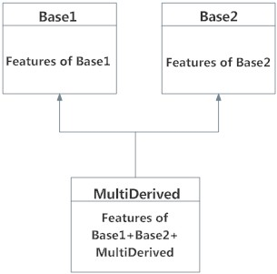Multiple Inheritance in Python

3. Multilevel inheritance: When we have child and grand child relationship.
class Person(object):
. . .
# Inherited or Sub class (Note Person in bracket)
class Child(Base):
. . .
# Inherited or Sub class (Note Child in bracket)
class GrandChild(Child):
. . . .
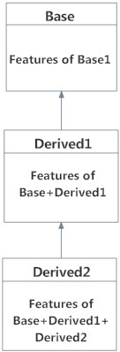
Multilevel Inheritance

Private members of parent class:
Python doesn't have any mechanism that effectively restricts access to any instance variable or method. Python prescribes a convention of prefixing the name of the variable/method with single or double underscore to emulate the behaviour of protected and private access specifiers.
We don’t always want the instance variables of the parent class to be inherited by the child class i.e. we can make some of the instance variables of the parent class private, which won’t be available to the child class.

All members in a Python class are public by default. Any member can be accessed from outside the class environment.

Example: Public Attributes
class employee:
def __init__(self, name, sal):
self.name=name
self.salary=sal
e1= employee(1000)
print(e1.salary)
Python's convention to make an instance variable protected is to add a prefix _ (single underscore) to it. This effectively prevents it to be accessed, unless it is from within a sub-class. This doesn't prevent instance variables from accessing or modifying the instance

Example: Protected Attributes
class employee:
def __init__(self, name, sal):
self._name=name # protected attribute
self._salary=sal # protected attribute

A double underscore __ prefixed to a variable makes it private. It gives a strong suggestion not to touch it from outside the class. Any attempt to do so will result in an AttributeError:
Example: Private Attributes
class employee:
def __init__(self, name, sal):
self.__name=name # private attribute
self.__salary=sal # private attribute
Python performs name mangling of private variables. Every member with double underscore will be changed to _object._class__variable. If so required, it can still be accessed from outside the class, but the practice should be refrained.
e1=Employee("Bill",10000)
print(e1._Employee__salary)
e1._Employee__salary=20000
print(e1._Employee__salary)

super() method and method resolution order(MRO)
In Python, super() built-in has two major use cases:
Allows us to avoid using base class explicitly
Working with Multiple Inheritance
super() with Single Inheritance:
In case of single inheritance, it allows us to refer base class by super().

class Mammal(object):
def __init__(self, mammalName):
print(mammalName, 'is a warm-blooded animal.')

class Dog(Mammal):
def __init__(self):
print('Dog has four legs.')
super().__init__('Dog') # instead of Mammal.__init__(self, 'Dog')

d1 = Dog()
The super() builtin returns a proxy object, a substitute object that has ability to call method of the base class via delegation. This is called indirection (ability to reference base object with super())

Since the indirection is computed at the runtime, we can use point to different base class at different time (if we need to).

Method Resolution Order (MRO):
It's the order in which method should be inherited in the presence of multiple inheritance. You can view the MRO by using __mro__ attribute.

Problem Definition:
1. For given program find output
Sr.No | Program | Output
1 | class Rectangle:  def __init__(self, length, width):  self.length = length  self.width = width  def area(self):  return self.length * self.width  def perimeter(self):  return 2 * self.length + 2 * self.width  class Square(Rectangle):  def __init__(self, length):  super().__init__(length, length)  square = Square(4)  print(square.area()) | 16
2 | class Person:  def __init__(self, fname, lname):  self.firstname = fname  self.lastname = lname  def printname(self):  print(self.firstname, self.lastname)  class Student(Person):  def __init__(self, fname, lname, year):  super().__init__(fname, lname)  self.graduationyear = year  x = Student("Wilbert", "Galitz", 2018)  print(x.graduationyear) | 2018
3 | class Base1(object):  def __init__(self):  self.str1 = "Python"  print("First Base class")  class Base2(object):  def __init__(self):  self.str2 = "Programming"  print("Second Base class")  class Derived(Base1, Base2):  def __init__(self):  # Calling constructors of Base1  # and Base2 classes  Base1.__init__(self)  Base2.__init__(self)  print("Derived class")  def printStrs(self):  print(self.str1, self.str2)  ob = Derived()  ob.printStrs() | First Base class  Second Base class  Derived class  Python  Programming

2. Assume that a bank maintains two kinds of accounts for customers, one called as savings account and the other as current account. The savings account provides simple interest and withdrawal facilities but no cheque book facility. The current account provides cheque book facility but no interest. Current account holders should also maintain a minimum balance Rs. 500 and if the balance falls below this level, a service charge is imposed to 2%.
Create a class account that stores customer name, account number and type of account. From this derive the classes cur_acct and sav_acct to make them more specific to their requirements. Include necessary member functions in order to achieve the following tasks:
- Accept deposit from a customer and update the balance.
- Display the balance.
- Compute and deposit interest.
- Permit withdrawal and update the balance.
- Check for the minimum balance, impose penalty, necessary and update the balance.

Result

Books/ Journals/ Websites referred:

  - Reema Thareja , “Python Programming: Using Problem Solving Approach”, Oxford University Press, First Edition 2017, India
  - Sheetal Taneja and Naveen Kumar,” Python Programing: A Modular Approach”, Pearson India, Second Edition 2018, India
  - https://www.programiz.com/python-programming/methods/built-in/super
  - https://www.tutorialsteacher.com/python/private-and-protected-access-modifiers-in-python
  - https://www.geeksforgeeks.org/inheritance-in-python/

Implementation details:

class account:
def __init__(self,name,accNo,type,balance):
self.name=name
self.accNo=accNo
self.type=type
self.balance=balance
def details(self):
print("Name :",self.name)
print("Account No :",self.accNo)
print("Account Type :",self.type)
print("Balance Ammount :",self.balance)
def withdraw(self,ammouut):
if(self.balance>ammouut):
self.balance-=ammouut
else:
print("Insufficient Balance")
return self.balance
def deposit(self,ammount):
self.balance+=ammount
return self.balance
class current(account):
def __init__(self,name,accNo,balance=0):
super().__init__(name,accNo,"Current",balance)
print("Customer has Checkbook Facility")
def deposit(self, ammount):
return super().deposit(ammount)
def withdraw(self, ammount):
if(self.balance<500):
print("A service charge of 2% is imposed as the balance is less than Rs. 500")
self.balance-=10
print("New Balance Rs.",self.balance)
return super().withdraw(ammount)
def details(self):
print("Customer has Checkbook Facility")
return super().details()
class savings(account):
def __init__(self, name, accNo,balance=0):
super().__init__(name, accNo,"Savings", balance)
print("Customer has Interest Facility")
def deposit(self, ammount):
return super().deposit(ammount)
def withdraw(self, ammouut):
return super().withdraw(ammouut)
def interest(self,p,t):
r=0.05
return (p*(1+(r*t)))
def details(self):
print("Customer has Interest Facility")
return super().details()
def main():
cond=True
while cond:
print("Welcome to The Bank")
name=input("Enter customer's Name: ")
accNo=input("Enter Account No: ")
print("""Kindly select an account to proceed futher
(1) Current Account
(2) Savings Account
(3) Exit""")
n=input("Enter a choice: ")
if n=="1":
obj=current(name,accNo)
k=True
while k:
print("""Kindly Select an Option
(1) Deposite ammount
(2) Withdraw ammount
(3) Display Details
(4) Exit
""")
n1=input()
if n1=='1':
obj.deposit(float(input("Enter ammount to deposit: ")))
elif n1=='2':
obj.withdraw(float(input("Entter ammount to withdraw: ")))
elif n1=="3":
obj.details()
elif n1=='4':
k=False
cond=False
else:
print("Enter correct option Only!")
elif n=="2":
obj=savings(name,accNo)
k=True
while k:
print("""Kindly Select an Option
(1) Deposite ammount
(2) Withdraw ammount
(3) Display Details
(4) Compute Interest for customer
(5) Exit
""")
n1=input()
if n1=='1':
obj.deposit(float(input("Enter ammount to deposit: ")))
elif n1=='2':
obj.withdraw(float(input("Entter ammount to withdraw: ")))
elif n1=="3":
obj.details()
elif n1=="4":
p=float(input("Enter Principle ammount: "))
t=float(input("Enter time in years: "))
print("The computed return is: ",obj.interest(p,t))
elif n1=='5':
k=False
cond=False
else:
print("Enter correct option Only!")
elif n=="3":
cond=False
else:
print("Enter correct option Only!")
main()

Output(s):
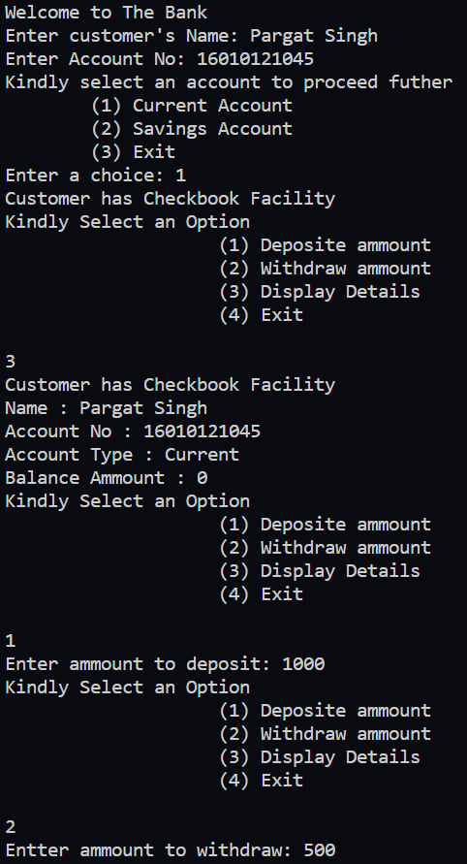
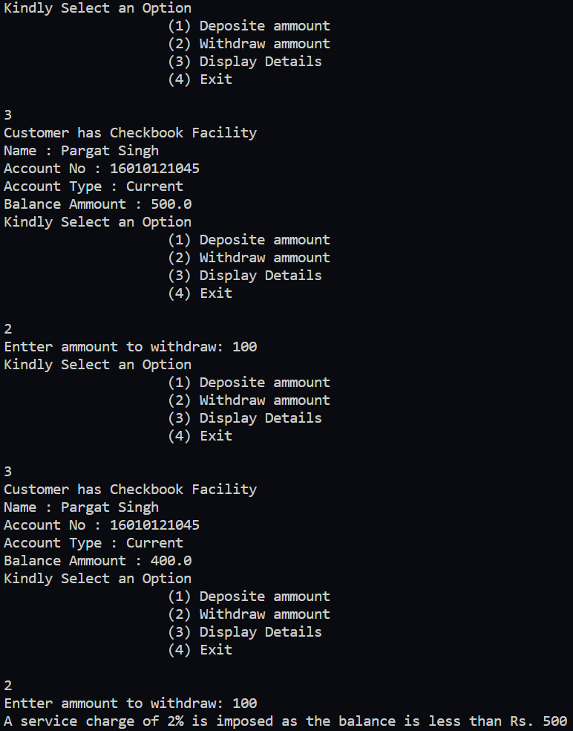
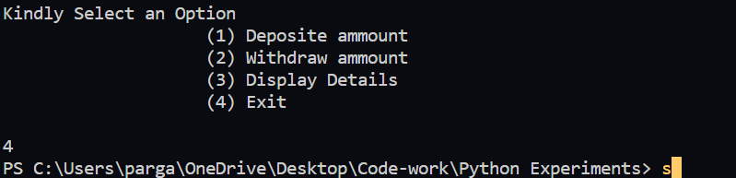
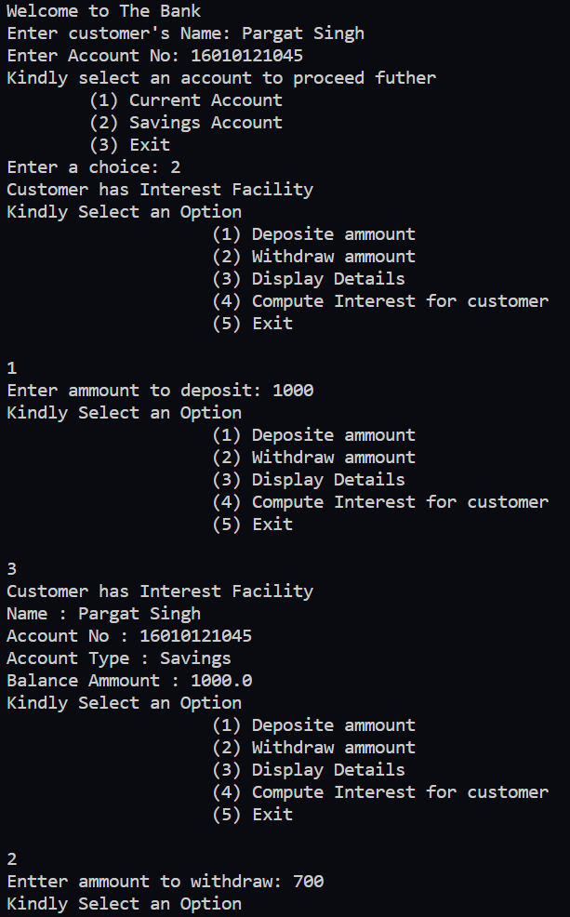
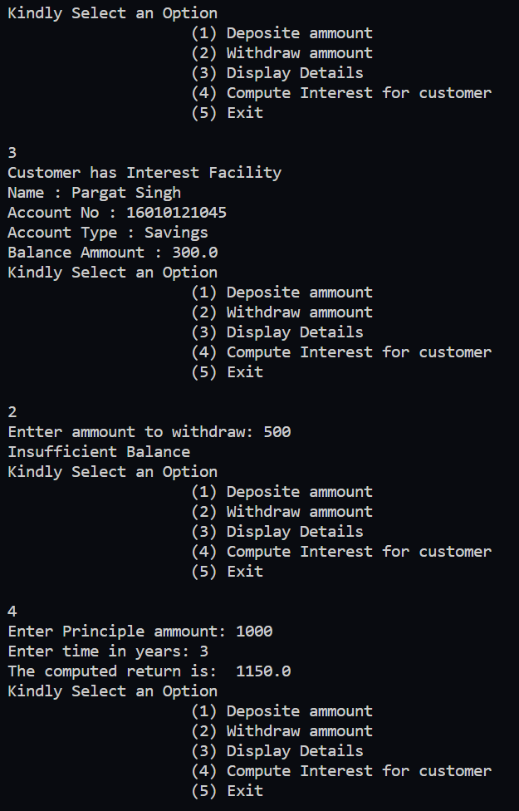

Conclusion:
Understood Inheritance in python and successfully implemented in the give program.

Post Lab Questions:

- Explain isinstance() and issubclass() functions with example?

isinstance() method is used to check if an object is an instance of a class. It takes two parameters. The first one is the object to test and the second one is a single class or a tuple of classes. It will check if the first parameter object is an instance of class classinfo. If the second parameter is a tuple of classes, it will check if the first object is an instance of any of the classes in the tuple.

n = 14
print('n is int:', isinstance(n, int))

issubclass() method is used to check if a class is a subclass of a different class. It will check if class is a subclass of another class classinfo or a tuple of classes. Note that for both methods, the second parameter is a single class or a tuple of classes.
class parent:
pass
class child(parent):
pass
class grandChild(child):
pass
print("Is grandChild subclass of child",issubclass(grandChild,child))
print("Is child subclass of grandChild",issubclass(child,grandChild))

Date: _____________ Signature of faculty in-charge

